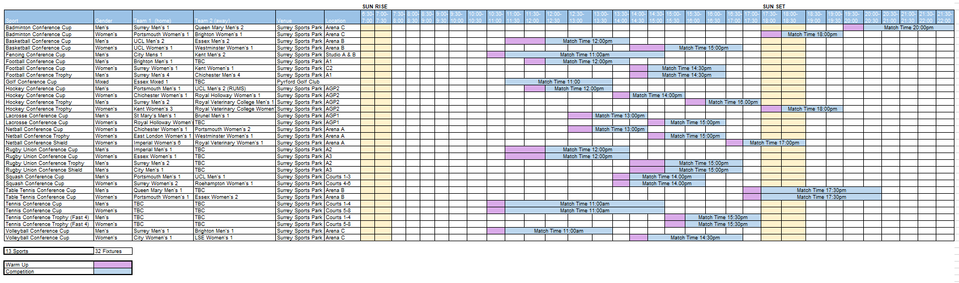**

**BUCS SOUTH EASTERN CONFERENCE FINALS TIMETABLE 2024**