




University of Warwick and Coventry University

BUCS Midlands
Conference Cup Finals 2026

Introduction
Congratulations to all teams who have qualified for the BUCS Midlands Conference Cup Finals 2026. The University of Warwick and Coventry University are excited to be hosting this event on behalf of the East and West Midlands regions.
Please can all team captains read this information in full.

Key Event Info:
• Date: Wednesday 11th March 2026
• Venues:
- Warwick Sports and Wellness Hub, Leighfield Road, Coventry, CV4 7EU (what3words: ///choice.melon.groom) – BLUE SQUARE
- Cryfield Sports Pavilion, Leighfield Road, Coventry, CV4 7AL (what3words: ///league.factor.flows) – RED CIRCLE
- Warwick Tennis Centre and Westwood pitches, Westwood Campus, Kirby Corner Road, Coventry, CV4 8UW (what3words: ///gross.plays.aware) – YELLOW TRIANGLE
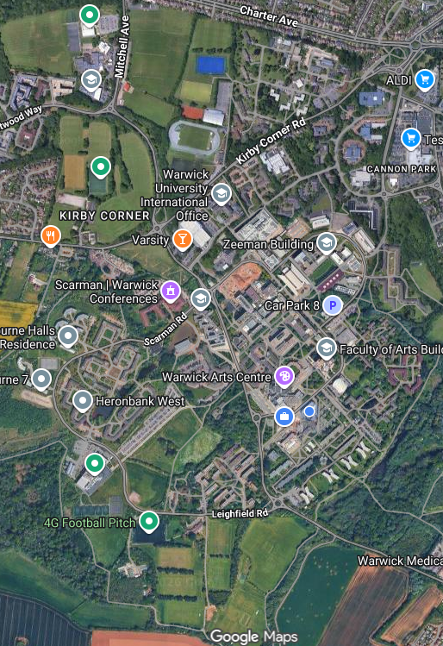
- Sport and Recreation Centre EB, Whitefriars St, Coventry CV1 2DS (What3words: ///email.complains.appeal) – not shown on map.
- Coventry Golf Club, Saint Martins Road, Finham, Coventry, CV3 6RJ (what3words: ///galaxy.joined.unit)

Competition Schedule
Please see at the bottom of this event guide the full competition schedule. You can
also find it on the BUCS Event page HERE.

Registration
Please arrive at least 1 hour before your fixture start time to register. When you arrive at the venue, please go to the following registration desk where a member of staff or volunteer will show you to your allocated changing room. If you arrive late, we may not be able to delay the start of the fixture due to facility constraints.
VENUE | STAFF MEMBER | CONTACT NUMBER
Warwick Sports and Wellness Hub | Marcus Henson | 07716648373
Cryfield Sports Pavilion | TBC | TBC
Warwick Tennis Centre | TBC | 024 7615 0690
Sport and Recreation Centre (Coventry Uni) | Charlie Fitzpatrick | 07947 341987

Refreshments
University of Warwick has a number of food and beverage outlets on site to provide on the day. Additionally, food trucks will be in the main Piazza, by the bus terminal, for use to all guests on the day. Most take card, though some may operate cash only, so please be aware.
At Coventry Sport and Recreation Centre, we have a café in the building with hot and cold drinks, as well as some small snacks and sandwiches. This facility is a ‘card only’ café. Due to being a city campus, there are some small convenience stores within walking distance of the venue.

Marketing
Any supporting University marketing/communications/media/social media team, please register upon arrival on the Sport & Fitness Reception Desk. No media accreditation is formally required, however please ensure that appropriate consent processes are followed, and teams are mindful of other students/external groups on-site.
For social media use, please use the official hashtag for BUCS Conference Cup Finals: #BUCSConferenceFinals2026
For any enquiries, please contact Marketing Manager: Tom Hartwell tom.hartwell@warwick.ac.uk

Filming and Photography
Filming and photography will be taking place across campus at all venue sites by various bodies. If you would prefer not to be photographed, please contact Marketing Manager Tom Hartwell tom.hartwell@warwick.ac.uk
Livestreaming and Drones
If any attending university teams, athletes, coaches or spectators want to Livestream please email all three of the following members of staff with the details surrounding you livestreaming use:
- Iain Mckinney – Head of Sports Delivery: iain.mckinney@warwick.ac.uk
- Marcus Henson – BUCS Coordinator: Marcus.Henson@WarwickSU.com
- Rob Eddon – Head of Sport: robert.eddon@coventry.ac.uk

Drone usage will not be allowed on the day. If anybody if found using a drone, they will be asked to cease filming, and if they do not comply, they will be asked to leave campus by Campus Security.

Spectators
Each team competing in the BUCS Midlands Conference Cup Finals are responsible for the behaviour of their spectators and management. Any behaviour that is deemed to be in breach of the BUCS Midlands Conference Cup Finals 2026 Code of Conduct will follow the breaches/sanctions.

Travel and Transport
All teams must fill out the Transport Form to declare how they are travelling to this event, no later than Monday 9th March.

Parking – Coventry Sport and Recreation Centre
There is limited on-street parking outside the venue, however, there is a car park next to the sports centre at the end of Whitefriars St and another, a short walking distance from the venue (Gosford Street Car Park – CV1 5ED) available for use.

Parking – University of Warwick
Students driving can park at the below addresses, though parking for visitors is charged as a pay by phone service as described above.

- Sports Hub and Cryfields parking: University of Warwick, Car Park 8A, Coventry CV4 8UW
- Westwood parking: Westwood Campus, Kirby Corner Road, Coventry, UK CV4 8AH

Prices from the 1st September 2025
- Up to 2 hours - £3.50
- Up to 3 hours - £4.50
- Up to 4 hours - £5.50
- Full day (until 8am the next day) - £8.50

Evening parking charges
- Evenings - £2.50 from 5pm-8am (if you have bought an all-day ticket this includes the evening and you do not need to buy another ticket).

Coaches – Coventry Sport and Recreation Centre
There is no specific coach bays/parking near the venue, there is enough room on Whitefriars St for them to drop off and turn around.

Coaches – University of Warwick

Any teams travelling by coach can have their students dropped off at Sports Hub for Sports Hub or Cryfield locations, and Westwood campus, however, there is a coach park on campus for them between pick up and return: Warwick University Coach Park (bluebell car park), Coventry CV4 7EQ.

Public Transport
Local bus and train services can be found through Coventry.
Buses - From Coventry City Centre & Coventry rail station to Coventry Sport and Recreation Centre
The National Express 11 or 12x connect Coventry rail station to the sports centre with a short walk
These run about every 8 mins
Cost: £5.20 for a day ticket - this can be purchased by using a contactless card on the buses ticket reader, or alternatively downloading the mTicket app: https://nxbus.co.uk/coventry/mticket
Buses - From Coventry City Centre & Coventry rail station to University of Warwick
These services all connect the University to Coventry City Centre and Coventry rail station:
National Express 12X - this express service goes directly from the City Centre to campus, via Coventry Rail station.
National Express 11 & 11U - these services come from Coventry City Centre and Coventry rail station to campus via Earlsdon
Typical Travel Times to University Warwick: 30mins
Cost: £5.20 for a day ticket - this can be purchased by using a contactless card on the buses ticket reader, or alternatively downloading the mTicket app: https://nxbus.co.uk/coventry/mticket

Code of Conduct for Players and Spectator Guidelines
The Conference Finals are a celebration of our teams’ achievement and should be a fun and positive experience for all players, officials, and spectators.
Players and spectators are requested to conduct themselves in a respectful manner. No form of abuse will be tolerated, and our staff, security and volunteers will take appropriate action where necessary.
Our sporting venues are “no alcohol zones”, so teams must be aware that they cannot bring alcohol to any venue (items will be confiscated by security).
Alcohol can be purchased at The Dirty Duck on Campus but must be consumed within this space and cannot be taken pitch-side.
All team captains must sign the Code of Conduct form on behalf of their team by Monday 9th March.

Security
There will be a team of Security staff and student volunteers to help ensure you have a safe and enjoyable experience. If you need any help or assistance our team are on hand to assist you. Please also note that our campus has CCTV coverage.
Do not leave valuables unattended in changing rooms. We cannot guarantee the safety of items left unattended.

Medical Provision
In an emergency call 999.
Once phoned 999, please call Campus Security on 024 7652 2222 if attending University of Warwick.
Please inform a site staff member if attending Coventry Sport and Recreation Centre, who will in turn follow Emergency Action Procedures (i.e first aid, and/or emergency services)
What is classed as an emergency - Any situation where there is immediate risk to life, safety or security – yours, another people, or property. It’s a situation that happening now and needs an immediate response.

Report a Non-Emergency
Inform – Either the Duty Officer or Event Manager (Coventry University)
CALL – 024 7652 2083 (University of Warwick)
There will be an ambulance crew on-site (St Johns Ambulance) who will be based at the Sports Hub.
Additionally, we will have pitch side support from the Coventry University physiotherapy students and staff.
The Emergency Action Plan (EAP) for all University owned venues will be sent to the participating teams. AEDs are available at each location including instruction manuals.

BUCS Regulations
All HOME teams (first named team on BUCS Play) are responsible for providing all relevant equipment and kit needed, as if it were being hosted at their venue.
If there are any kit clashes, the home team should change to an alternative kit, agreed by both institutions in advance.
If the event that the fixture cannot take place, the fixture will revert to the home team and be played on another date agreed by both institutions.
BUCS Play:
• BUCS will update the fixture details on BUCS Play.
• Team sheets need to be completed on BUCS Play by all teams.
• All competitors should bring their student ID cards for verification.
• Home teams are responsible for submitting the scores on BUCS Play as usual.

Weather
TBC.
If weather impacts any fixtures, the institutions affected will be informed as soon as possible with alternative arrangements being made

Over-running of fixtures
With an event of this size, there might be times where fixtures over ran. If this happens, please contact your Event Location lead who will coordinate any further steps.

Changing Rooms
Each competitive team competing will have a dedicated changing room before and after the fixture. Once ready, each team must remove their items from the changing room and place them next to the court/pitch etc in which they are competing in. All items are left at the owner's risk, and the University of Warwick or Coventry University take no liability for items being left.
Lost and found – if any items are found, they will be taken to Sport and Fitness Reception.

Match Officials
University of Warwick and Coventry University will appoint all Match Officials in line with Appendix-5-BUCS-Match-OfficialsRequirements.
Please treat all Match Officials with respect and in line with the Code of Conduct.
If a Match Official has not arrived for your fixture, please report to your Point of Contact at registration or the Event Leads – See Key Contacts.

Medal Presentations
There will take place across various areas across campus. After your fixture is finished a volunteer/member of staff will take you to the presentation area – please clear the venue of your belongings.
The presentations will start shortly after your fixture has finished. To note – we have multiple fixtures finishing in close times to each other so presentation start times may vary depending on those presenting.

Key Contacts
Name | Contact Number
Marcus Henson – University of Warwick Event Lead | 07716648373
Iain McKinney – University of Warwick Event Lead
Charlie Fitzpatrick – Coventry University Event Lead | 07947 341987
Rob Eddon – Coventry University Event Lead | 07375 049979
Coventry University Protection Services | 02477655555
Warwick Campus Security | 02476 522222

BUCS Midlands Conference Finals 2026 – Competition Schedule

TBC

