

BUCS South Eastern Conference Finals 2026

Event Guide

1. Introduction
Congratulations to all teams who have qualified for the BUCS South Eastern Conference Finals 2026. Team Surrey are excited to be hosting this event on behalf of the South East Region, with the help of the University of Surrey.
Please can all team captains read this information in full.
Key Event Info:
- Date: Wednesday 11th March 2026
- Venues:
- Surrey Sports Park, Richard Meyjes Rd, Guildford GU2 7AD
- Pyrford Golf Club, Warren Lane, Pyrford, Woking, Surrey,
GU22 8XR

2. Competition Schedule
Please find below the competition schedule:
Sport | Fixture | Warm-Up | Start | Venue
Badminton | Men’s Southeastern Conference Cup | 20:00 | 20:30 | Surrey Sports Park, Richard Meyjes Rd, Guildford, GU2 7AD  Arena B
Badminton | Women’s Southeastern Conference Cup | 17:30 | 18:00 | Surrey Sports Park, Richard Meyjes Rd, Guildford, GU2 7AD  Arena B
Basketball | Men’s Southeastern Conference Cup | 12:00 | 12:30 | Surrey Sports Park, Richard Meyjes Rd, Guildford, GU2 7AD  Arena B
Basketball | Women’s Southeastern Conference Cup | 15:00 | 15:30 | Surrey Sports Park, Richard Meyjes Rd, Guildford, GU2 7AD  Arena B
Fencing | Men’s Southeastern Conference Cup | 11:30 | 12:00 | Surrey Sports Park, Richard Meyjes Rd, Guildford, GU2 7AD  Studio A & B
Football | Men’s Southeastern Conference Cup | 11:00 | 11:30 | Surrey Sports Park, Richard Meyjes Rd, Guildford, GU2 7AD  Grass Pitch A2
Football | Women’s Southeastern Conference Cup | 14:00 | 14:30 | Surrey Sports Park, Richard Meyjes Rd, Guildford, GU2 7AD  Grass Pitch C1
Football | Men’s Southeastern Conference Trophy | 14:00 | 14:30 | Surrey Sports Park, Richard Meyjes Rd, Guildford, GU2 7AD  Grass Pitch A2
Golf | Men’s Southeastern Conference Cup |  | 11:00 | Pyrford Golf Club, Warren Lane, Pyrford, Woking, Surrey, GU22 8XR
Hockey | Women’s Southeastern Conference Cup | 11:30 | 12:00 | Surrey Sports Park, Richard Meyjes Rd, Guildford, GU2 7AD  AGP2
Hockey | Women’s Southeastern Conference Trophy | 13:30 | 14:00 | Surrey Sports Park, Richard Meyjes Rd, Guildford, GU2 7AD  AGP2
Hockey | Men’s Southeastern Conference Cup | 15:30 | 16:00 | Surrey Sports Park, Richard Meyjes Rd, Guildford, GU2 7AD  AGP2
Hockey | Men’s Southeastern Conference Trophy | 17:30 | 18:00 | Surrey Sports Park, Richard Meyjes Rd, Guildford, GU2 7AD  AGP2
Lacrosse | Men’s Southeastern Conference Cup | 12:30 | 13:00 | Surrey Sports Park, Richard Meyjes Rd, Guildford, GU2 7AD  AGP1
Lacrosse | Women’s Southeastern Conference Cup | 14:30 | 15:00 | Surrey Sports Park, Richard Meyjes Rd, Guildford, GU2 7AD  AGP1
Netball | Southeastern Conference Cup | 13:00 | 13:30 | Surrey Sports Park, Richard Meyjes Rd, Guildford, GU2 7AD  Arena A
Netball | Southeastern Conference Trophy | 15:00 | 15:30 | Surrey Sports Park, Richard Meyjes Rd, Guildford, GU2 7AD  Arena A
Netball | Southeastern Conference Shield | 17:00 | 17:30 | Surrey Sports Park, Richard Meyjes Rd, Guildford, GU2 7AD  Arena A
Rugby Union | Women’s Southeastern Conference Cup | 11.00 | 12.00 | Surrey Sports Park, Richard Meyjes Rd, Guildford, GU2 7AD  Grass Pitch A1*
Rugby Union | Men’s Southeastern Conference Cup | 11.00 | 12.00 | Surrey Sports Park, Richard Meyjes Rd, Guildford, GU2 7AD  Grass Pitch B1
Rugby Union | Men’s Southeastern Conference Trophy | 14:00 | 15:00 | Surrey Sports Park, Richard Meyjes Rd, Guildford, GU2 7AD  Grass Pitch A1*
Rugby Union | Men’s Southeastern Conference Shield | 14:00 | 15:00 | Surrey Sports Park, Richard Meyjes Rd, Guildford, GU2 7AD  Grass Pitch B1
Squash | Men’s Southeastern Conference Cup | 13:30 | 14:00 | Surrey Sports Park, Richard Meyjes Rd, Guildford, GU2 7AD  Courts 3-4
Squash | Women’s Southeastern Conference Cup | 13:30 | 14:00 | Surrey Sports Park, Richard Meyjes Rd, Guildford, GU2 7AD  Courts 5-6
Table Tennis | Men’s Southeastern Conference Cup | 19:30 | 22:30 | Surrey Sports Park, Richard Meyjes Rd, Guildford, GU2 7AD  Arena C
Table Tennis | Women’s Southeastern Conference Cup | 19:30 | 22:30 | Surrey Sports Park, Richard Meyjes Rd, Guildford, GU2 7AD  Arena C
Tennis | Men’s Southeastern Conference Cup | 10:30 | 11:00 | Surrey Sports Park, Richard Meyjes Rd, Guildford, GU2 7AD  Courts 3-5
Tennis | Women’s Southeastern Conference Cup | 10:30 | 11:00 | Surrey Sports Park, Richard Meyjes Rd, Guildford, GU2 7AD  Courts 6-8 (DOME)
Tennis | Men’s Southeastern Conference Trophy (FAST4) | 15:00 | 15:30 | Surrey Sports Park, Richard Meyjes Rd, Guildford, GU2 7AD  Courts 3-5
Tennis | Women’s Southeastern Conference Trophy (FAST4) | 15:00 | 15:30 | Surrey Sports Park, Richard Meyjes Rd, Guildford, GU2 7AD  Courts 6-8 (DOME)
Volleyball | Men’s Southeastern Conference Cup | 10:30 | 11:00 | Surrey Sports Park, Richard Meyjes Rd, Guildford, GU2 7AD  Arena C
Volleyball | Women’s Southeastern Conference Cup | 14:00 | 14:30 | Surrey Sports Park, Richard Meyjes Rd, Guildford, GU2 7AD  Arena C

3. Registration
Please arrive at least 1 hour before your fixture start time to register. When you arrive at the venue, please go to the following registration desk where a member of staff will show you to your fixture location and changing room (if allocated). If you arrive late, we may not be able to delay the start of the fixture due to facility constraints.
Venue | Registration desk | Point of contact
Surrey Sports Park | Sports Park Reception | Charlie Mascall: 07792724971
Pyrford Golf Club | Golf Club Reception | Luke Bennet: 07754915879

4. Travel and Transport

4.1 Surrey Sports Park
There is parking available at Surrey Sports Park. Visitors must register their number plate at the main reception. Parking is free of charge so long as it is registered at reception. Parking access is monitored via an Automatic Number Plate Recognition (ANPR) system and by a private company, so Team Surrey does not take any responsibility for parking fines that may be issued if you do not register your vehicle.
Coaches and mini busses must drop-off teams at the following locations:
- Surrey Sports Park: Main Car Park (see appendix and head for minibus/coach parking)
Coaches then need to park in this location if there is space or will be redirected into the main car parks where there are 350 spaces.
Car parking will need to be planned, so please fill out the transport form above so we can plan accordingly. Parking is on a first come and first serve basis. Please do not park on any of the double yellow lines if the car park becomes full. The Sports Park has the authority to issue parking tickets if vehicles are parked illegally.

4.2 Pyrford Golf Club
Car parking is available at the golf club.

5. Code of Conduct for Players & Spectator Guidelines
The Conference Finals are a celebration of our teams’ achievement and should be a fun and positive experience for all players, officials, and spectators.

Players and spectators are requested to conduct themselves in a respectful manner. No form of abuse will be tolerated, and our staff, security and volunteers will take appropriate action where necessary.

Our sporting venues are “no alcohol zones”, so teams must be aware that they cannot bring alcohol to any venue (items will be confiscated by security). Alcohol can be purchased at various locations at the sports park on the day.

6. Stewards & Operations Staff
There will be a team of operations staff and student volunteers to help ensure you have a safe and enjoyable experience. If you need any help or assistance our team will be on hand to assist you.

Please also note that our campus has CCTV coverage.

Do not leave valuables unattended in changing rooms or around the sports park.

7. Medical Provision
In the event of a life-threatening incident please call 999 immediately.

7.1 Surrey Sports Park
There will be Surrey Sports Park physios who will be based across the inside and outside of the sports park from 10:00-21:00
An ambulance will be present alongside two paramedics and a first responder.
There will also be multiple First Aiders from our operations team who will be based across the sports park and available in case of an emergency.
Surrey Sports Park is based next to the Royal Surrey County Hospital, so in the event of a serious injury students will be taken to this hospital.
If you need assistance on the day, there will be staff around the site to contact. If a physio is not nearby, please communicate with a marshal and they will radio our medical team to respond accordingly.

7.2 Pyrford Golf Club

If you need assistance on the day, then please contact the duty manager in the club house or front of house team at reception.
The following phone numbers can be contacted if you require assistance over the phone when out on the course and you will be directed to one of the members of staff at the venue.
01483 723555
07772 600488

8. BUCS Regulations
All HOME teams (first named team on BUCS Play) are responsible for providing all relevant equipment and kit needed, as if it were being hosted at their venue.
If there are any kit clashes, the home team should change to an alternative kit, agreed by both institutions in advance.
Medals will be presented after all finals.
If the fixture cannot take place, the fixture will revert to the home team and be played on another date agreed by both institutions.
BUCS Play:
- BUCS will update the fixture details on BUCS Play.
- Team sheets need to be completed on BUCS Play by all teams.
- All competitors should bring their student ID cards for verification.
- Home teams are responsible for submitting the scores on BUCS Play as usual.

9. Match Officials
Team Surrey will appoint and pay all Match Officials in line with Appendix-5-BUCS-Match-Officials-Requirements.
Please treat all Match Officials with respect and in line with the Code of Conduct.
If a Match Official has not arrived for your fixture, please report to your Point of Contact at registration or the Event Lead, Kirsty Baguley - 07970 232 937.

10. Key Contacts
Name | Phone number
Event Lead | Charlie Mascall - 07792724971
BUCS Contact | Kristian Jackson - 07751932549
Surrey Sports Park | 01483 689 111
Pyrford Golf Club | 01483 723 555

11. Cost
Each institution will be invoiced by Surrey Sports Park for £6.00 per player, per squad, based on the squad sizes submitted by BUCS. For example, badminton has 6 squad members, therefore the entry fee is 6 x £6.00. This money will cover the costs associated with hosting the Finals event. Each institution will be invoiced after the event.

12. Food and drink

12.1 Activity Zone
Each entry fee will include a free lunch voucher for each athlete to use the food vendor which will be based in the Activity Fan Zone. There will also be an Emergency Medical Tent set up in the activity zone for first aid support.
Pitchside Coffee will also be open inside the sports park if people wish to use these catering outlets on the day as well. However, students redeeming their free lunch voucher can only do so in the outside activity zone.

13. Changing Rooms
Surrey Sports Park has 14 changing rooms and therefore these will be allocated in priority order to the sports which would require them the most. You will be given a swipe access card on the day when you sign in and you will be responsible for returning the swipe card to reception at the end of the day. A student card will be required as a deposit to ensure that these are returned after your universities fixture finishes.

14. Appendix

14.1 Outdoor facilities
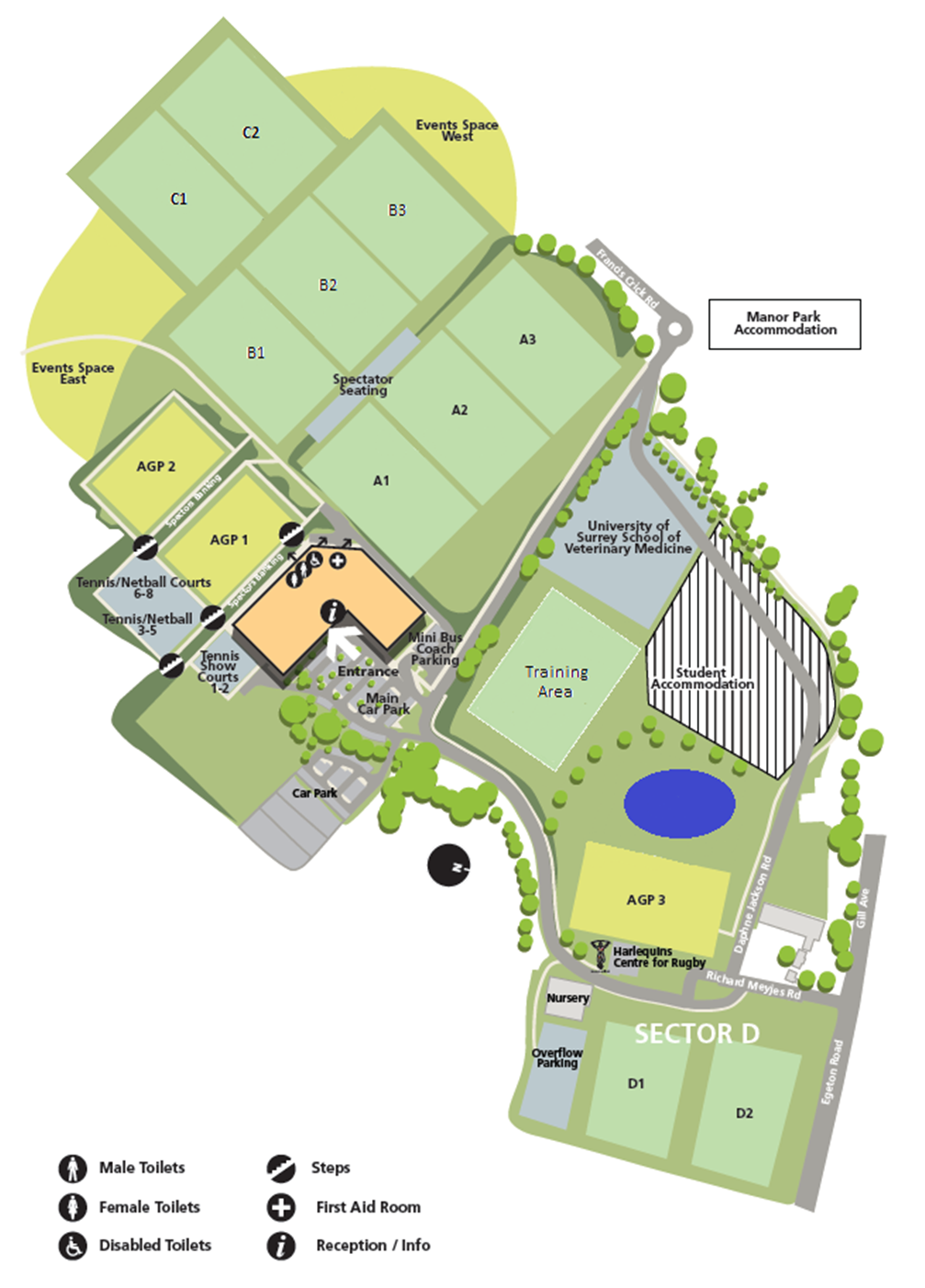
ACTIVITY ZONE

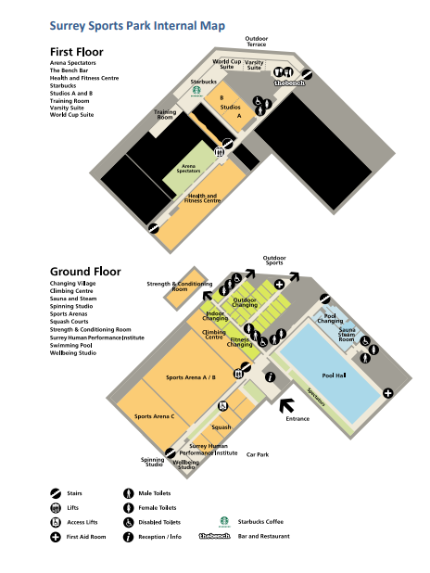
14.2 Indoor facilities

